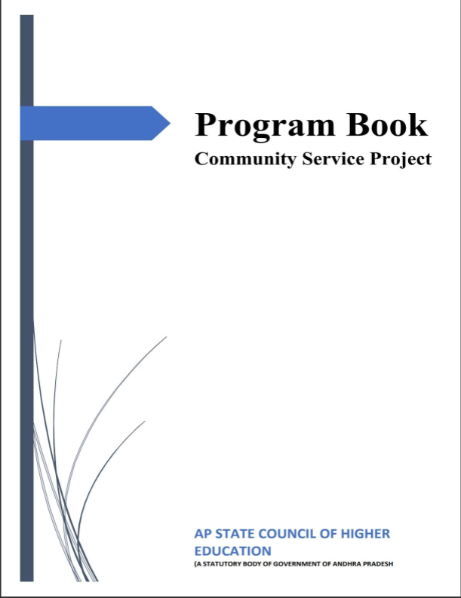

Name of the students | K. Raju
Name of the college | NEC
Registration number | 25475A0513
Period of CSP
Name of the community | Yallamanda, Narasaraopeta
COMMUNITY SERVICE PROJECT REPORT
Name of the college | NEC
Department | Computer Science and Engineering
Name of the guide | M.Satyam Reddy
Duration of the CSP
Name of the student | K. Raju
Year of study | III
Registration number | 25475A0513
Date of submission
STUDENT’S DECLARATION
I, K. Raju student of Bachelor of Technology, bearing Reg.No 25475A0513 of Department of Computer Science and Engineering, Narasaraopeta Engineering College do hereby declare that we have completed the mandatory community service from …..…...... to …............ , in the locality of Yallamanda, Narasaraopeta. Under the faculty guidance of Mr. K. Jaya Prakash of the Computer Science and Engineering department in Narasaraopeta Engineering College.

Signature and date
Endorsements
Faculty Guide : ( Mr.M.satyam reddy)
Head of the Department : ( Dr. S. N. Tirumala Rao )
Principal : ( Dr. S. Venkateswarlu )
CERTIFICATE FROM OFFICIAL OF THE COMMUNITY
This is to certify that K. Raju, Reg.No 25475A0513 of Narasaraopeta Engineering College underwent community service in Yallamanda, Narasaraopeta from …............... to …...............
The overall performance of community service volunteer during their community service is found to be good.
Authorized signature with date and seal
ACKNOWLEDGMENT
We are very glad to express our special thanks to Mr. .M.satyam reddy, Guide for the project, who has inspired us to select this topic, and for his valuable advises in preparing this project topic.
We express our sincere thanks to Dr. S. N. Tirumala Rao, Head of the CSE Department, for his encouragement and support in carrying out this project successfully.
We are thankful to Dr. S. Venkateswarlu, principal of NEC, Narasaraopeta for having allowed us to deliver this project.
We express our gratitude to our management and the people who helped us directly and indirectly in accomplishing our community service project.
Project Associated by
K. Raju ( 25475A0513 )
S. Anilbabu ( 25475A0535 )
R. Siva ( 25475A0566 )
CONTENTS :
ECOSYSTEM SUSTAINABILITY MANAGEMENT 8
1. EXECUTIVE SUMMARY 8
2. OVERVIEW OF THE COMMUNITY 9
3. COMMUNITY SERVICE 10
4. ACTIVITY LOG 13
5. OUTCOMES DESCRIPTION 17
6. CONCLUSION 26
STUDENT SELF-EVALUATION FOR THE CSP : 28
EVALUATION BY THE PERSON IN-CHARGE : 30
7. PHOTOS 31
ECOSYSTEM SUSTAINABILITY MANAGEMENT
1. EXECUTIVE SUMMARY
COMMUNITY : Yallamanda, Narasaraopeta
ACTIVITIES :
- Created awareness on ecosystem sustainability and environmental protection among the villagers
- Discussed the role of healthy ecosystems (water, soil, air, forests and biodiversity) in sustaining community life
- Provided knowledge on environmental indicators, waste segregation and carbon-reduction practices
- Introduced the Eco Sustainability Management Website and its features to students and thereby to the community
- Encouraged community participation in issue reporting, tree plantation, clean-up drives and conservation campaigns
LEARNING OBJECTIVES & OUTCOMES :
- To learn about the consequences that poor waste, water and resource management have on the ecosystem, children’s health, development and well-being
- To consider some of the barriers and options for improving environmental sustainability in the future using technology
- Understood the environmental conditions and resource usage of the selected area
- Derived the factors affecting the ecosystem sustainability of the community
2. OVERVIEW OF THE COMMUNITY
YALLAMANDA VILLAGE OVERVIEW :
Gram Panchayat | : yallamanda
Mandal | : Narasaraopeta
District | : Palnadu
State | : Andhra Pradesh
Pin code | : 522611
Area | : 4480 hectares
Population | : 17336
Households | : 4212
Nearest Town | : Narasaraopeta (6km)
ABOUT YALLAMANDA :
Yallamanda is a village located in Narasaraopet Mandal of Palnadu district in Andhra Pradesh. Around 691 families reside in Yallamanda village. yallamanda village is administered by Sarpanch(Head of village) who is elected every five years. As per the Census India 2011, yallamanda village has population of 2581 of which 1271 are males and 1310 are females. The population of children between age 0-6 is 281 which is 10.89% of total population. The literacy rate of yallamanda village is 50.14% out of which 57.75% males are literate and 42.75% females are literate.
3. COMMUNITY SERVICE
ECOSYSTEM :
An ecosystem is a community of living organisms such as plants, animals and microorganisms that interact with each other and with the non-living parts of their environment such as air, water, soil and sunlight. Forests, lakes, rivers, farmland and even a village and its surroundings are all ecosystems. A healthy ecosystem provides clean air, fresh water, fertile soil, food and a safe place to live.
SUSTAINABILITY :
To keep our environment healthy for the present and for future generations we need to practice sustainability. Sustainability means meeting the needs of today without reducing the ability of future generations to meet their own needs. The word “eco” comes from the Greek word oikos that means ‘home’. Adopting sustainable practices and promoting them in the community, school and workplace prevents the spread of pollution and the overuse of natural resources. Ecosystem sustainability deals with both individual responsibility as well as community management of resources.
How can we keep our environment clean To keep the environment clean we need to:
- Keep our house clean.
- Keep our neighbourhood clean.
- An effective drainage system is essential as stagnated water allows breeding of mosquitoes. Have you heard of garbage bins with labels such as “Biodegradable wastes”, “paper waste”, “Biodegradable green waste” and “Non degradable wastes”? Some of the common garbage items generated at our homes are: wastepaper, plastic carry bags, vegetable peels, used batteries, stale food items, used pens, old clothes, and broken glass.
- Identify the garbage items you will put in each of these dust bins shown below.
- If possible, name the community centre or area where such practice is being adopted.
Maintaining sustainable practices reduces pollution, saves natural resources and lowers the risk of environmental and health problems caused by careless use of resources. It also increases community pride and positively impacts relationships among neighbours. Keep reading for the practices and the technology that help contribute to the overall sustainability of an ecosystem.
PROBLEM STATEMENT :
Environmental information about resources, waste, emissions and ecosystem health is usually scattered, handled manually and reported late. Because of this, pollution, deforestation, water shortage and resource wastage are noticed only after serious damage has happened, and communities have no simple way to report or track environmental issues.
PROJECT : ECO SUSTAINABILITY MANAGEMENT WEBSITE
As our community service project we designed an Eco Sustainability Management Website. It is an Ecosystem Sustainability Management platform that monitors environmental resources, biodiversity, carbon emissions, waste and ecosystem health. The core features of the website are given below.
CORE FEATURES :
- Sustainability Dashboard – Real-time overview of environmental performance, sustainability scores, resource consumption and key indicators.
- Ecosystem Monitoring – Track biodiversity, forests, water bodies, soil quality, air quality and other ecosystem health indicators.
- Environmental Data Analytics – Collect, visualize, compare and analyze environmental data using charts, graphs, maps and reports.
- Resource Management – Monitor and manage water, energy, land, forests and other natural resources to reduce overuse and waste.
- Waste Management – Track waste generation, segregation, recycling, reuse, disposal and waste-reduction targets.
- Carbon & Emission Tracking – Calculate carbon footprint and monitor greenhouse-gas emissions with reduction targets.
- Biodiversity Management – Maintain information about species, habitats, endangered organisms, conservation areas and biodiversity trends.
- GIS & Interactive Maps – Display ecosystems, protected areas, pollution hotspots, natural resources and environmental changes geographically.
- Alerts & Notifications – Provide alerts for pollution spikes, deforestation, water-quality problems, excessive resource consumption or other environmental risks.
- Sustainability Goals & KPIs – Set targets such as carbon reduction, water conservation, renewable-energy adoption and biodiversity improvement, then track progress.
- Compliance & Reporting – Generate sustainability reports and track compliance with environmental regulations, standards and organizational policies.
- User & Role Management – Separate access for administrators, environmental officers, organizations, researchers, communities and general users.
- Issue Reporting – Allow users to report pollution, illegal dumping, deforestation, wildlife threats or other environmental issues with photos and location information.
- Education & Awareness – Provide articles, guides, sustainability tips, campaigns and educational resources.
- Community Engagement – Support volunteering, conservation campaigns, tree-planting activities, clean-up drives and community participation.
- Predictive Analytics – Use historical and real-time data to identify environmental risks and predict future ecosystem conditions.
- Data Security & Administration – Secure authentication, permissions, data backup, audit logs and administrative controls.
ONE LINE SOLUTION :
An Ecosystem Sustainability Management website monitors environmental resources, biodiversity, carbon emissions, waste, and ecosystem health while providing analytics, alerts, reporting, and actionable solutions for sustainable management.
SUSTAINABLE LIVING :
Sustainable living means using natural resources such as water, energy, land and forests in correct proportion to meet the needs of a person and a community without wasting them. A person can reduce their environmental footprint by saving water and electricity, reducing plastic, segregating waste and planting trees. The resource pyramid of reduce, reuse and recycle depicts the order in which we should manage the things we use.
PREVENTION :
- Increased awareness of the reasons for environmental degradation and resource wastage.
- Regular tree plantation, water conservation and rainwater harvesting.
- Avoiding single-use plastic and increasing reuse, recycling and composting.
- Saving electricity and water and moving towards renewable energy.
- Monitoring environmental data regularly through the website and acting on alerts.
- Setting one’s own sustainability goals for improvement rather than blindly copying others.
4. ACTIVITY LOG
WEEK 1 :
Day & Date | Description of Daily Activity | Learning Outcome | Inc. Sign
Day – 1 | Some of our classmates had formed a group and selected the topic “Ecosystem Sustainability Management” and an area called yallamanda. | I have learned how to select a topic and an area that must be surveyed
Day – 2 | This is the 2nd day of our project. We headed towards the village officials to take permission from them and explained about our project in detail. After sometime they’ve given approval | Taking Permissions from Village Officials
Day – 3 | On this day to create awareness among villagers. So we had to know the topic in detail. We all gathered information on ecosystems, resources, waste and carbon emissions and put it short in notes | Gathering Information in detail about selected topic
Day – 4 | On fourth day, To make our topic clear and easier to villagers we had selected new methods or techniques like ppt, chart representation, and planned the modules of the sustainability website. | Learned new techniques or strategies
Day – 5 | Today we meet a family. As it taken time to make them understand how to protect the environment and use resources sustainably | I learned how to communicate and make them understand
Day – 6 | This is last day of our first week project. On this day we asked villagers they are getting right at our topic or not .They might be able to understand or not | It makes clear that I have choosen right topic and I’m going with a flow
WEEKLY REPORT :
WEEK - 1
OBJECTIVE OF ACTIVITY DONE :
To select the community and the topic of ecosystem sustainability, take
permissions and gather information for the Eco Sustainability Management Website.
DETAILED REPORT: On First day of week-1, As by forming a group we
selected the Yallamanda village and the topic ecosystem sustainability. I have
learned how to select an area that must be surveyed. On Second day, We have met
several village heads like sarpanch and officers to get permission for providing
awareness in their Village. I have learned how hard enough to get permission from
officials. On third day, to provide awareness we need detailed information so
gathered it. It’s a prolonged task. I had learned that we need to have great
knowledge in that topic. On fourth day, to make it clear and easier for villagers
we imported new methods like PPT, charts, etc. and planned the features of the
website. On fifth day, we met a family and talked about our topic I had gained
much confidence after that. On last day of our first week we just cross-check with
villagers that what we are saying is right.
WEEK 2 :
Day & Date | Description of Daily Activity | Learning Outcome | Incharge Signature
Day – 1 | On first day of second week. We had started increasing awareness and developing the website modules | I have learned to have much patience
Day – 2 | On second day, we visited the village water source and waste collection points. To tell more about saving water and managing waste | I had learned deeply about topic by going there
Day – 3 | On third day, we had completed our oral work | I learned to complete my work within limited time
Day – 4 | We decided to visit the High School, explained to students about waste segregation, tree plantation and the sustainability website | I learned how to explain sustainability to students in simple language
Day – 5 | we collected the first week documentation | First week documentation was ready
Day – 6 | Second week documentation, weekly report and overall, all work had been finished perfectly | Overall work had been completed successfully
WEEKLY REPORT :
WEEK - 2
OBJECTIVE OF ACTIVITY DONE :
To spread awareness on ecosystem sustainability, complete the survey and prepare
the project documentation.
DETAILED REPORT : We are having tough time in the second week managing
everything. We sort out all our work by distributing to each Others it makes easy
and time saving. After wrapping all the work and Finished visiting all the houses.
Lastly, Villagers, Officials and who took part in our project we thanked all of
them for their support and their guidance. After that we visited the water source,
waste collection points and the High School. we completed our first- and
second-week documentation only because of teamwork. After completion of that we
had shown our weekly report to our mentor of our project for any corrections or
changes that had to be done. We worked so hard for getting accurate information
about our topic. Completion of that we had hard copies of our prepared
Documentation. Finally, we had completed our project with document
5. OUTCOMES DESCRIPTION
QUESTIONAIRRE PREPARED FOR THE SURVEY :
This study is carried with the help of following questionnaire:
- Name of the person
- Age of the person (in years):
- Gender of a person
- Marital status
- How many kids are there in the family?
- Occupation of a person
- Have you experienced any survey related to environment before?
- Do you know what an ecosystem and sustainability mean?
- Where do you get drinking water for your house?
- Is there any scarcity of water during summer?
- How do you use and save water at home?
- Is the municipality collecting your garbage regularly?
- Do you dispose of wet waste and dry waste separately?
- What do you do with plastic waste and used plastic bags?
- Do you burn waste or garbage near your house?
- Do you have a proper drainage system for discharging of wastewater
- Are there any stagnant water reserves near or in your house?
- How many trees or plants do you have around your house?
- Do you use LED bulbs, solar energy or other energy-saving methods?
- On a typical day, how many hours of electricity do you use?
- Do you use cloth bags instead of plastic carry bags?
- Do you have a toilet facility at home?
- Are you satisfied with the sanitation of your local environment?
- Have you attended any tree-plantation or clean-up programme in your area?
- Would you use a website or mobile app to report environmental problems?
- Are you aware of any government schemes for environment protection?
- Do you have any suggestions to improve the environment of your village?
PROBLEMS IDENTIFIED IN THE COMMUNITY :
- Scarcity of water and over-dependence on groundwater
- Improper waste disposal (wet and dry waste mixed, open dumping)
- Open burning of waste and poor sanitation practices
- Loss of trees and low green cover
- No system to monitor and report environmental problems
- Low awareness of sustainability and resource conservation
SHORT-TERM AND LONG-TERM ACTION PLAN FOR POSSIBLE SOLUTIONS FOR THE PROBLEMS IDENTIFIED :
- Sustainable water management and requested sarpanch for additional water supply during summer season, along with rainwater harvesting.
- To change people’s minds on how and where to dispose of waste, segregate wet and dry waste and build compost pits using government funds.
- Improving sanitation practices in villages through awareness programs and stopping the burning of waste.
- Cut back a little each day e.g., use one less plastic bag per day so that every day you cut down is a small success to be celebrated. Plant trees and organize tree-plantation and clean-up drives for future social gatherings.
- Requested sarpanch to support an environmental monitoring and reporting facility, and introduced the Eco Sustainability Management Website for reporting issues with photos and location.
- Improving awareness of resource conservation and encouraging sustainable lifestyle choices.
COMMUNITY AWARENESS PROGRAMMES CONDUCTED :
- Cleanliness and Waste Segregation Awareness Program.
- Water and Energy Conservation Awareness.
- Motivating local people to raise the demands with concerned authorities to improve the quality of civic services, water supply and waste collection as per the norms and requirements.
- Tree Plantation and Ecosystem Awareness Program.
REPORT OF THE MINI-PROJECT :
As per the objectives framed to initiate community service, I have selected a community named Yallamanda, one of the areas listed by the government, to inform the people of the community about ecosystem sustainability and to introduce the Eco Sustainability Management Website. From the preliminary observation and survey, I came to know that the people living in that community depend mainly on daily wages and most of them are not aware of the proper use and protection of natural resources.
Most of the residents do not have proper awareness of waste management, water conservation and environmental protection practices. In the COVID pandemic residents of the community were badly affected due to the lack of proper awareness of health and hygiene practices, which are closely linked to a clean and sustainable environment. By considering all the above I have decided to educate the people of the community on ecosystem sustainability and to provide a website where environmental issues can be monitored and reported.
Conducted survey:
Methodology is said to be a procedure or a way in which the project work has been done in this project the methodology consists of following steps:
- Data collection
- Sample design
- Analysis Data collection :
Data collection methodology can be broadly classified as
- primary data and
- secondary data
1. Primary data:
Primary data are those that are originally in character and are collected as fresh. All the primary data is the information collected for the first time. There are several methods in which the data is collected. I have selected the questionnaire method to conduct my survey. Questionnaire is a formularized set of questions which are arranged to collect the information useful for the proposed study the questionnaire is structured containing a limited number of questions, which are away to understand in the google forms Sampling method for study The sample method or a plan is the procedure or way in which sampling has been done. As no project can be done taking into consideration the whole of the population the concept of sampling is used as per the concept of sampling only some samples are taken from the universe to find out the result convenience method is taken as the sampling method.
Sample size:
This refers to the number of items to be selected from the universe the sample taken for this study is 10 As per the methodology I have initiated my survey with a questionnaire as a Google form in the selected community with the help of local volunteers. I have directly interacted with the people of the community. I have asked the questions related to water availability, garbage disposing, garbage collection, energy use, tree cover and sustainable habits of their families, and the usage and disposing of plastic and other waste etc. I asked about the disposal of the wet waste and dry waste and came to know that they were disposing of the whole kitchen waste and dry waste all in a single bin. And the bins were collected once for every 3 days by the municipality workers.
Coming to the sustainable habits I asked about the usage of plastic bags, water saving, electricity use and tree plantation, by this we came to know that they were not completely aware of sustainable practices but few of them were following some practices like using cloth bags and reusing water for plants. Next to that I have asked about the water availability and mode of drinking water supply. I came to know that they have a ground water facility with the help of a hand pump. They were not facilitated with the corporation water supplement; this was the major issue they are facing.
AWARENESS CREATED :
Educated the area residents by sticking charts on the walls with some information about water conservation, waste segregation and the value of trees and provided them with some personal counselling about the cleanliness of surroundings, saving natural resources and sustainable habits and explained to them the value of education which help them to improve their lifestyle. I have also shown them some pictures and the screens of the Eco Sustainability Management Website and tried to make them aware about the need for good environmental practices. I have also displayed some videos regarding problems faced due to the lack of sustainability as a part of implementation of program as per my knowledge I have practices which may help to lead a sustainable life. I had also made them aware by communicating with them with simple language which they can easily understand.
Individual And Community Environmental Responsibility:
Both individual and community responsibility are important for the well-being of an individual as well as the community. The health of an ecosystem may be affected by human activity, availability of water and other natural resources. Participation of local and government organizations becomes essential in promoting ecosystem sustainability. Taking care of our surroundings to keep them clean and free from pollution constitutes individual responsibility.
Community sustainability is the practice of protecting the environment and managing the resources of a population through the organized efforts of society, public and private organizations, communities and individuals. There are various activities and programs undertaken by the government and local organizations to protect the environment and keep the surroundings free from pollution. Some of these activities and programs are listed below:
- Maintain cleanliness of the villages, towns, cities and localities through proper garbage disposal.
- Ensure that prescribed environmental standards in markets, industries and water supply are strictly followed.
- Organize environmental protection programmes, including
- Tree-plantation drives and conservation campaigns, for instance, The Swachh Bharat Mission and Vanamahotsav that are being run by the government.
- Various awareness programs have been undertaken against the spread of pollution and for the protection of water bodies, forests, wildlife and air quality.
- The Namami Gange programme is an example of one such programme.
- Organize community clean-up drives and school eco-clubs to build environmental habits in growing children.
- Set up waste-collection centres, compost units and water-treatment facilities for the public either free of cost or at highly subsidized rates.
Individual sustainable habits:
The following are some necessary sustainable habits.
- Saving water: Turning off taps, fixing leaks and reusing water keeps our natural water sources from being wasted.
- Saving energy: Switching off lights and fans when not in use and using LED bulbs and solar energy reduces carbon emissions.
- Reducing plastic and reusing: Carrying cloth bags and reusing containers reduces the plastic that pollutes soil and water.
- Segregating waste: Keeping wet waste and dry waste separate helps in composting and recycling and keeps the surroundings clean.
- Planting and protecting trees: Trees give oxygen, shade and shelter to wildlife and reduce carbon dioxide in the air. Cutting trees without need must be avoided.
Domestic sustainability :
We dust and mop our houses to keep them clean and free from dirt, flies and germs. Disposal of garbage in the allotted bins ensures clean surroundings and prevents breeding of disease-causing organisms. Kitchen waste can be turned into compost for kitchen gardens, and used items can be repaired, reused or recycled.
Clean water and energy:
Before it is consumed, water should be filtered or boiled and stored in clean containers. Rainwater should be collected and recharged into the ground wherever possible so that the groundwater level is maintained.
Using resources with care:
- Water, electricity and fuel should be used only as much as required.
- While cooking and travelling, it is important to choose energy-efficient methods such as pressure cookers, shared transport or cycling to reduce emissions.
- Leftover food and agricultural waste should be composted or reused and stored in a cool and clean place, rather than being thrown on roads or burnt.
Green habits Regular walking, cycling, tree planting and outdoor activities keep both people and the environment in good condition. Abstaining from burning waste, plastic, tobacco and other pollutants; these damage the air, soil and water, and their continuous use harms the lungs, kidneys, heart and the ecosystem as a whole.
You may have noticed that littering and spitting is quite common in public places and near bus stops. We must stay away from such habits and try to convince others to do the same. Community sustainability is the practice of protecting the environment and promoting the well-being of a population through the organized efforts of society, public and private organizations, communities and individuals.
There are various activities and programs undertaken by the government and local organizations to maintain the environment and keep it free from pollution. Some of these activities and programs are listed below:
- Maintain cleanliness of the villages, towns, cities and localities through proper garbage disposal.
- Ensure that prescribed environmental standards in markets, industries and water supply are strictly followed.
- Tree-plantation and conservation programmes for forests, wildlife and water bodies run by the government.
Various awareness programs have been undertaken against environmental problems of national concern like water pollution, air pollution, plastic waste, deforestation, loss of biodiversity and climate change. The Swachh Bharat Mission is an example of one such programme. What happens if proper sustainable conditions are not followed, a condition that interferes with the normal functioning of the ecosystem is called ecosystem degradation.

 | Ecosystem Sustainability
 | A. Natural resources (Water, soil, air, forests) | B. Living organisms (Plants, animals, biodiversity)
 | C. Human pressures (Waste, emissions, overuse of resources) | D. Sustainable actions (Monitoring, alerts, awareness, conservation)

Cause:
- Unsustainable lifestyle: Insufficient waste segregation, burning of waste, excessive use of vehicles and wastage of water and electricity are some of the factors that are responsible for the above-mentioned ecosystem degradation.
- Consumption habits: Easily available single-use plastic and packaged products like carry bags, bottles and disposable cups lead to heavy waste and pollution. They can never replace the sustainability provided by reusable and natural alternatives such as cloth bags, steel bottles and leaf plates.
- Careless attitude: People who think that environmental protection is the job of someone else rather than their own, and who ignore littering, illegal dumping and cutting of trees, are more responsible for the damage to the ecosystem.
- Lack of monitoring: Absence of data, reporting systems and early alerts about pollution, deforestation and water quality also makes the problems grow unnoticed.
ENVIRONMENTAL FIRST RESPONSE:
While living, working or otherwise, one could come across an environmental problem such as a pollution spike, illegal dumping, deforestation or a fire. Timely intervention and immediate reporting can prevent further damage to the ecosystem and even save a life. You can be of great help in such situations if you have the basic knowledge of environmental first response.
Immediate action given to an environmental problem before the authorities arrive is called environmental first response.
However, the concerned authorities should be informed after the first response
1. Pollution spike: When there is a sudden increase in smoke, dust, chemical smell or water pollution, the area becomes unsafe. The following first response can help
- Move people away from the polluted spot
- Cover the nose and mouth and avoid touching polluted water
- Report the issue through the website with a photo and location
- If there is breathing trouble, call the doctor immediately.
2. Illegal dumping and waste:
- Do not touch hazardous waste; keep a safe distance and take a photo.
- Report the exact location so that the waste can be removed and segregated.
- Inform the panchayat or the environmental officer
3. Deforestation and tree cutting:
- Note the place and time and take a clear photo.
- Report to the forest or local authority through the website if cutting is illegal.
4. Water-quality problems cause foul smell, change in colour and diseases such as typhoid, cholera and diarrhoea. They can result in serious illness if untreated water is used.
In mild water-quality problems there is change in colour, smell or taste of the water, floating waste and fish or plant death in ponds. In severe cases there is a sudden foul smell, foam, oil layers, illness among people and animals and finally loss of the water source. Water-quality problems may be caused by waste dumping, sewage, chemicals, fertilizers and lack of rainfall.
Affected water should not be used for drinking. Boil or filter water and use clean sources. Water can be made safe by boiling for a few minutes, filtering and using chlorine tablets, which are available free of cost at government health centers. Officials should be informed if need be.
5. Wildlife threats can be serious sometimes.
- Keep a safe distance from injured or trapped animals and do not try to catch them.
- In case of snake or dog bite, take the victim to a hospital immediately and inform the forest or animal-rescue helpline.
6. Fires and burning waste The first response depends upon the severity of the fire.
SCOPE OF COMMUNITY SERVICE:
Community sustainability helps to develop the community. Community development leads members to become responsible, develop sustainable lifestyles, empower, reduce poverty and increase economic opportunities. It takes place in particular geographic areas, focusing on identifying their needs, issues and strategies. It can also be concentrated on a particular area in identifying the problems of the environment.
OBJECTIVES:
- Selection of area .
- To study the environmental and resource conditions of the selected area.
- To study the factors affecting the ecosystem sustainability of the community.
- To create awareness on sustainability practices and to introduce the Eco Sustainability Management Website.
6. CONCLUSION
We visited the Yallamanda village, discussed with village sarpanch and people in the village. As the village has most of the problems like transportation, sanitation, water facilities, waste management, etc. We had surveyed on “ECOSYSTEM SUSTAINABILITY” conditions in Yallamanda village. Yallamanda is poor in the civic services. Village has an old hospital, but there are no government doctors in that hospital. Only once in a month health camp is conducting in the village and in emergency conditions the people have to go to Narasaraopeta hospital which is at 6 Kms from yallamanda village. Poor water connection is being provided by the Panchayati. Drainage system is not good. People are less aware of environmental problems and their causes. Most of the people are migrating from the village due to lack of facilities, transportation etc., and the village is away from the city.
Most of the people requested the government to improve water supply, sanitation and waste collection in their village. They need clean sanitation and clean water facilities from the government. Garbage collecting & cleaning should be done regularly. Environmental awareness programmes must be done by the government in order to help people to live a better life. To support this, we developed the Eco Sustainability Management Website, which monitors environmental resources, biodiversity, carbon emissions, waste and ecosystem health and provides analytics, alerts, reporting and actionable solutions for sustainable management. These are the main problems that has been rectified to provide a better life.
The following are the some of the sustainability practices to be followed for better life:
- Ecosystem health and sustainable resource use are the two factors that play an important role in a human’s life.
- The quality of life of human beings is mostly based on the health of the environment around them.
- The environment is maintained by using natural resources carefully and at the proper rate.
- Pollution and disease can be decreased if the community manages its waste and water properly and keeps its surroundings clean.
- Most of the plants and trees act as medicines and food for people and shelter for wildlife.
- Thus, protecting nature and using resources sustainably is essential.
- Pure drinking water is vital as it keeps us hydrated and helps in the functioning of our organs and removing toxins. Untreated water causes diseases like typhoid and cholera.
- Proper garbage disposal helps to keep the surroundings clean.
- Defecation in the open and open burning of waste is very unhygienic, and it needs to stop.
- Adopting sustainable practices not just benefits individuals but society as well.
- A sustainable community makes the nation stronger.
- Environmental protection is not the responsibility of only one person however, it is the responsibility of each and every person.
STUDENT SELF-EVALUATION FOR THE CSP :
Student Name
Registration No
Period of CSP
Date of Evaluation
Name of the Person In-charge
Address with Mobile number
Please rate your performance in the following areas :
Rating Scale : 1 is lowest and 5 is highest
1 | Oral Communication | 1 | 2 | 3 | 4 | 5
2 | Written Communication | 1 | 2 | 3 | 4 | 5
3 | Proactiveness | 1 | 2 | 3 | 4 | 5
4 | Interactive Ability with Community | 1 | 2 | 3 | 4 | 5
5 | Positive Attitude | 1 | 2 | 3 | 4 | 5
6 | Self-confidence | 1 | 2 | 3 | 4 | 5
7 | Ability to Learn | 1 | 2 | 3 | 4 | 5
8 | Work Plan & Organization | 1 | 2 | 3 | 4 | 5
9 | Professionalism | 1 | 2 | 3 | 4 | 5
10 | Creativity | 1 | 2 | 3 | 4 | 5

11 | Quality of Work Done | 1 | 2 | 3 | 4 | 5
12 | Time Management | 1 | 2 | 3 | 4 | 5
13 | Understanding the Community | 1 | 2 | 3 | 4 | 5
14 | Achievements of Desired Outcomes | 1 | 2 | 3 | 4 | 5
15 | OVERALL PERFORMANCE | 1 | 2 | 3 | 4 | 5
EVALUATION BY THE PERSON IN-CHARGE :
Student Name
Registration No
Period of CSP
Date of Evaluation
Name of the Person In-charge
Address with Mobile number
Please rate student’s performance in the following areas :
Rating Scale : 1 is lowest and 5 is highest
1 | Oral Communication | 1 | 2 | 3 | 4 | 5
2 | Written Communication | 1 | 2 | 3 | 4 | 5
3 | Proactiveness | 1 | 2 | 3 | 4 | 5
4 | Interactive Ability with Community | 1 | 2 | 3 | 4 | 5
5 | Positive Attitude | 1 | 2 | 3 | 4 | 5
6 | Self-confidence | 1 | 2 | 3 | 4 | 5
7 | Ability to Learn | 1 | 2 | 3 | 4 | 5
8 | Work Plan & Organization | 1 | 2 | 3 | 4 | 5
9 | Professionalism | 1 | 2 | 3 | 4 | 5
10 | Creativity | 1 | 2 | 3 | 4 | 5
11 | Quality of Work Done | 1 | 2 | 3 | 4 | 5

12 | Time Management | 1 | 2 | 3 | 4 | 5
13 | Understanding the Community | 1 | 2 | 3 | 4 | 5
14 | Achievements of Desired Outcomes | 1 | 2 | 3 | 4 | 5
15 | OVERALL PERFORMANCE | 1 | 2 | 3 | 4 | 5
7. PHOTOS
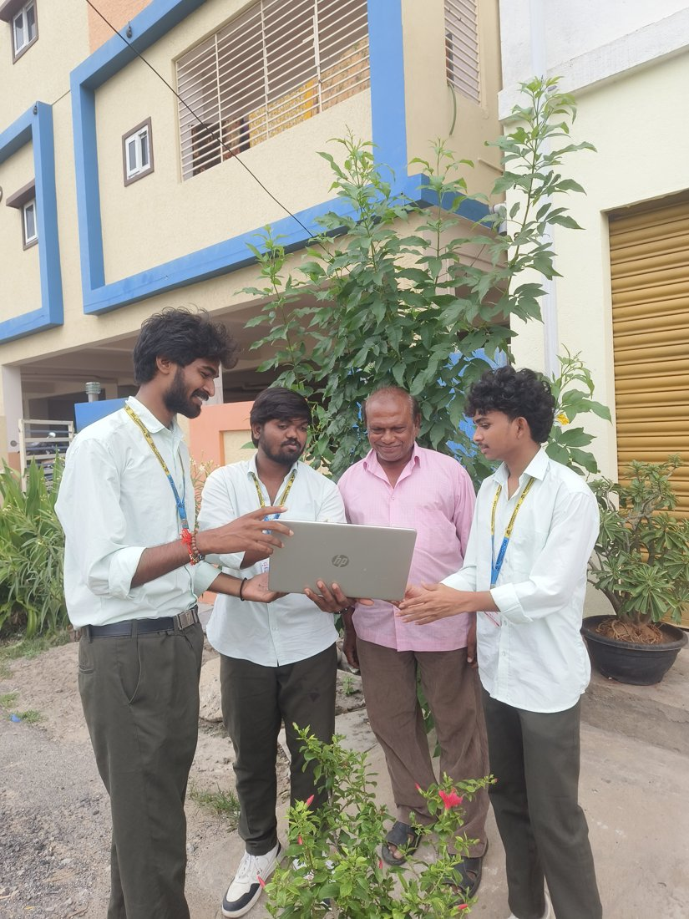 | 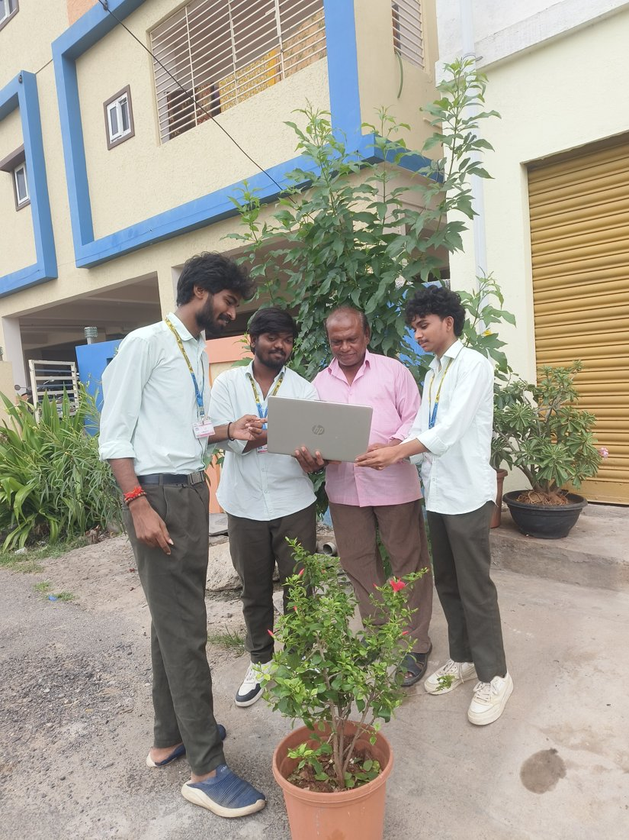
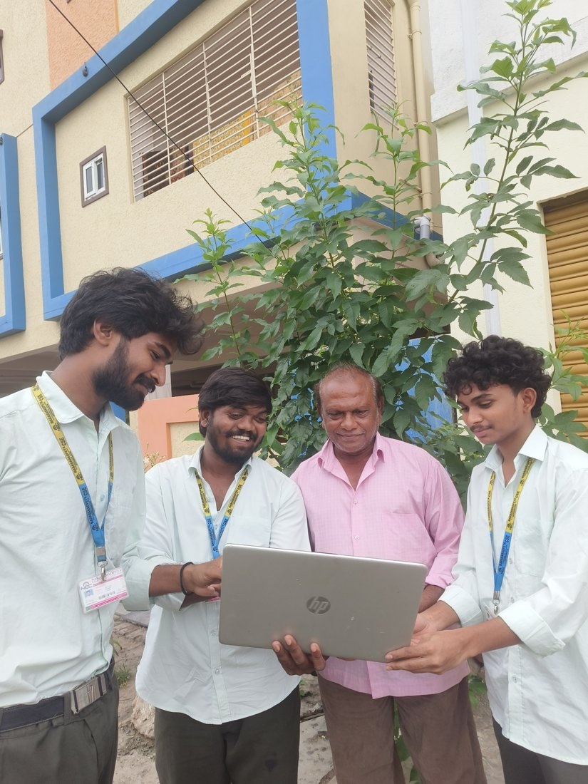 | 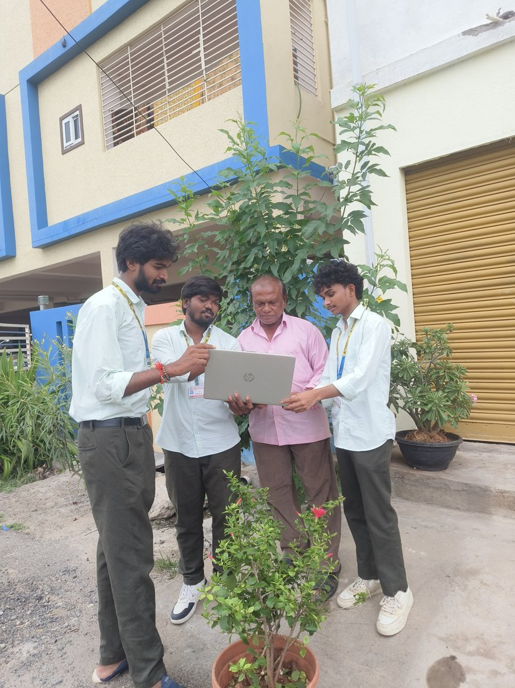
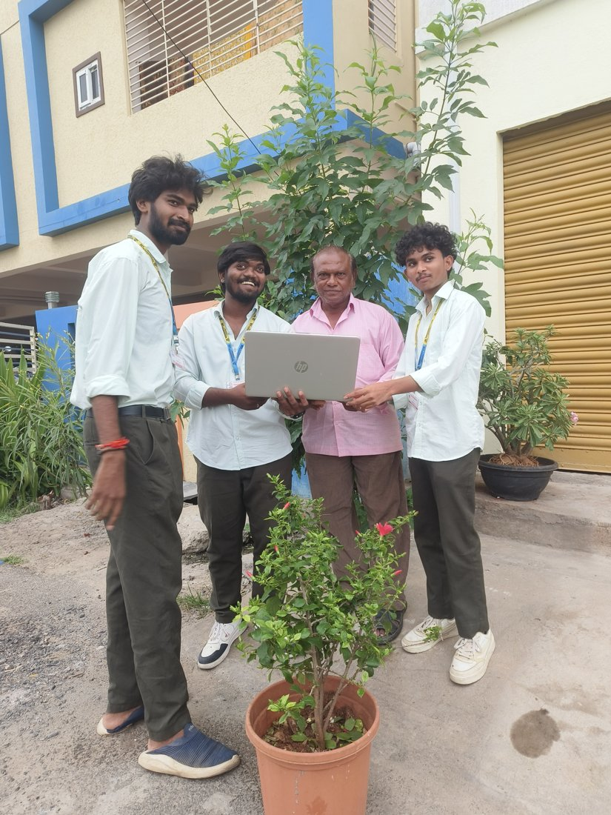 | 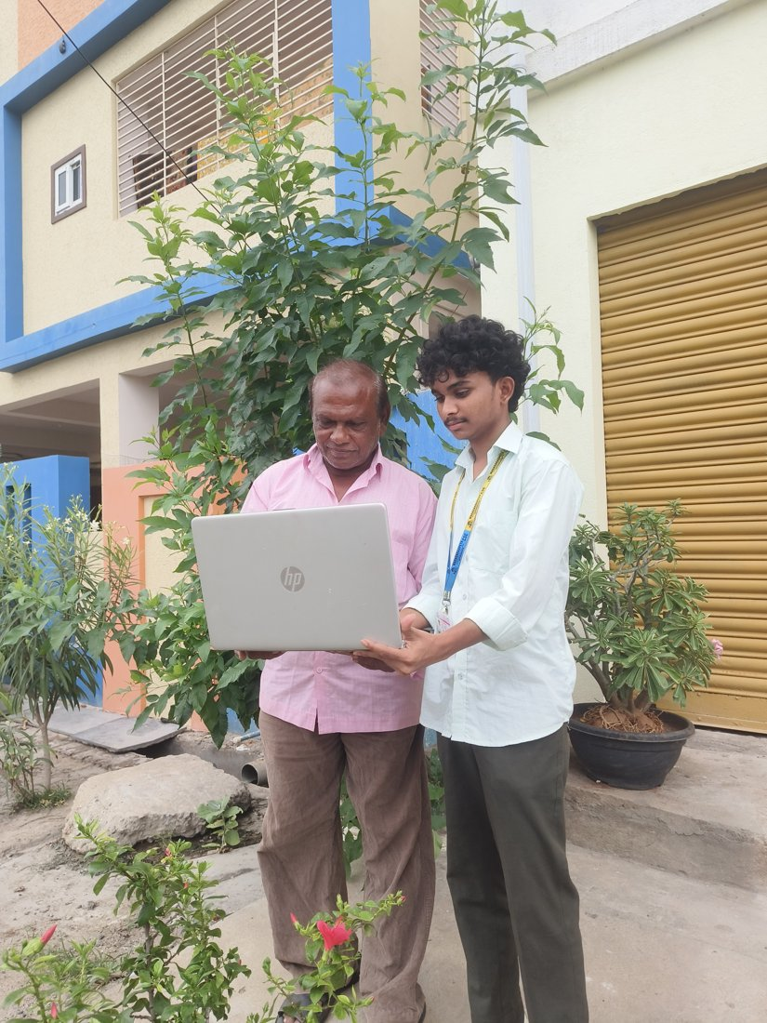
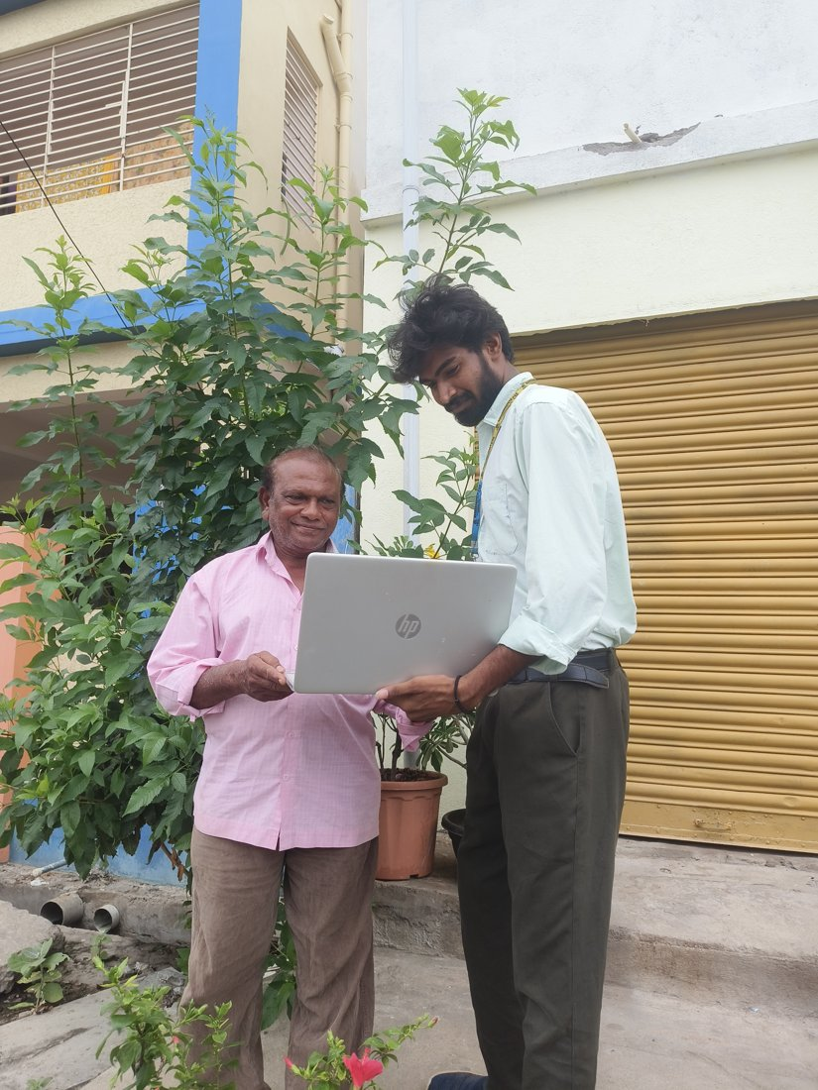 | 

